INTRODUCTION TO DATA MANAGEMENT
PROJECT REPORT
(Project Semester January-April 2025)

Tornado Insights: Tracking North America's Most Destructive Storms

Submitted by
Tanishka Soni

Registration No. 12319510
Program: B.tech Computer Science Engineering
Section: K23SK
Course Code: INT217

Under the Guidance of
Aashima Bansal UID:- 28968

Discipline of CSE/IT

Lovely School of Computer Science and Engineering
Lovely Professional University, Phagwara

CERTIFICATE

This is to certify that Tanishka Soni bearing Registration no. 12319510 has completed INT217
the project titled, “Tornado Insights: Tracking North America's Most Destructive Storms”
under my guidance and supervision. To the best of my knowledge, the present work is the
result of his/her original development, effort, and study.

Signature and Name of the Supervisor
Designation of the Supervisor
School of Computer Science and Engineering
Lovely Professional University
Phagwara, Punjab.

Date: 12/04/2025

DECLARATION

I, Tanishka Soni, student of B.tech Computer Science Engineering under CSE/IT Discipline at, Lovely Professional University, Punjab, hereby declare that all the information furnished in this project report is based on my own intensive work and is genuine.

Date: 12/04/2025 Signature
Registration No. 12319510 

ACKNOWLEDGMENT

I would like to express my heartfelt gratitude for the support and guidance that led to the successful completion of this project, titled ‘Interactive Tornado Dashboard and Data Analysis in Excel.
First and foremost, I am profoundly thankful to my project supervisor, Aashima Bansal, for her constant support, insightful feedback, and valuable guidance throughout the project. Their expertise helped me refine my analytical approach and focus on building a meaningful and data-driven dashboard.
I would also like to express my appreciation to Lovely Professional University for providing a conducive learning environment and access to the resources necessary to complete this project.
Special thanks to Microsoft Excel and the NOAA Storm Events Database, whose tools and datasets were instrumental in allowing me to conduct detailed tornado analysis and build an interactive dashboard that meets real-world disaster visualization needs.

Table of Contents

1. Introduction 5
2. Source of Dataset 6
3. Dataset Preprocessing 7
4. Analysis of the dataset (for each objective) 9
4.1 Tornado Frequency Over Time 9
4.2 State-wise Tornado Impact 11
4.3 Fujita Scale Distribution 12
4.4 Injuries & Fatalities Analysis 13
4.5 Financial Impact Analysis 14
4.6 Peak Tornado Months & Time of Day 16
4.7 Correlation Between Tornado Magnitude & Damage 17
4.8 Average Fujita Scale – Current Tornado Severity Level (Gauge Chart) 18
5. Conclusion 20
6. Future Scope 21
7. References 23

1. Introduction

Tornadoes are among the most destructive and unpredictable weather phenomena to affect North America. Their high-speed winds, wide-reaching paths, and potential for catastrophic damage make them a crucial subject of study in the field of atmospheric science and disaster preparedness. Over the years, tornadoes have resulted in the loss of thousands of lives and have caused billions in property and crop damage, particularly across the central and southeastern United States, often referred to as "Tornado Alley."

The primary aim of this project is to design a visually compelling, interactive, and insight-rich Excel dashboard that comprehensively analyzes tornado patterns and impacts in North America using historical data. This project marks the first milestone in my journey as a data science and visualization enthusiast, blending real-world datasets with analytical storytelling through the power of Microsoft Excel.

The data utilized in this project has been sourced from the NOAA Storm Prediction Center (SPC)—a division of the U.S. National Weather Service that specializes in forecasting and analyzing severe weather. Their database is a comprehensive repository of tornado events dating back to the 1950s and includes detailed records such as date and time of occurrence, Fujita scale (intensity), geographic origin, path dimensions (length and width), as well as human and economic impacts like injuries, fatalities, and financial losses.

This dashboard aims to simplify and visualize this vast and complex dataset through:
- Key Performance Indicators (KPIs) that summarize core statistics (e.g., total tornadoes, casualties, economic loss),
- Dynamic charts that reflect trends in tornado frequency, severity, seasonal patterns, and more,
- Slicers and filters that enable users to explore specific years, states, or damage levels interactively.

From a data science perspective, this project emphasizes the importance of data preprocessing, pattern recognition, and visualization design. It also explores the capability of Excel—not just as a spreadsheet tool, but as a robust platform for building interactive dashboards and decision-support tools.
By the end of this project, the dashboard serves as both:
- A useful analytical resource for stakeholders such as meteorologists, urban planners, emergency responders, and policy-makers, and
- A proof-of-concept portfolio piece for me, demonstrating my foundational skills in data preparation, pivot analysis, and dashboard design.
In essence, this project brings together data, design, and decision-making in a single, user-friendly interface. It not only showcases the real-world application of data analytics to natural disasters, but also highlights the role of beginner-friendly tools like Excel in deriving actionable insights from complex datasets.

2. Source of Dataset

The dataset utilized in this dashboard project was obtained from the Storm Prediction Center (SPC), a division of the National Oceanic and Atmospheric Administration (NOAA), United States. NOAA is the foremost government authority responsible for tracking atmospheric phenomena and issuing forecasts for severe weather events. The SPC specifically focuses on forecasting and archiving information about tornadoes and other extreme weather hazards, making it a highly reliable and credible source for weather-related data analysis.
The tornado data used for this project was sourced from NOAA's Severe Weather Database Files, which are made publicly available through their official portal: https://www.spc.noaa.gov/wcm/. This dataset is considered one of the most comprehensive historical records of tornado activity, spanning multiple decades, and is widely referenced in meteorological research and disaster risk assessments.

Key Attributes of the Dataset:
The raw dataset contains a vast number of fields that capture detailed attributes of each tornado occurrence, including:
- Event Identification: Unique tornado ID, date, and time of occurrence.
- Location Parameters: State, county, and geographic coordinates (latitude and longitude) for both the start and end points of the tornado path.
- Fujita Scale Rating: Tornado intensity classified from F0 to F5, which reflects the wind speed and potential damage severity.
- Path Metrics: Total length (in miles) and width (in yards) of the tornado track, useful in determining its reach and destructive area.
- Casualty Data: Number of people injured or killed, indicating the human impact of the event.
- Economic Losses: Estimated property damage and crop loss values, recorded in U.S. dollars.

Why This Dataset?
The dataset’s depth and granularity make it an ideal candidate for an interactive Excel dashboard. It supports multi-dimensional analysis across:
- Temporal trends (e.g., annual frequency of tornadoes),
- Geographic distribution (e.g., most affected states),
- Severity patterns (e.g., Fujita scale vs. damage),
- And human and financial impact metrics (e.g., casualties, losses).
The dataset’s structured format also allows for straightforward importing into Microsoft Excel and seamless integration into Pivot Tables, slicers, and dynamic charts.

Preparation for Dashboard Use:
After downloading the data in .xlsx format, significant preprocessing was performed to ensure the data was clean, structured, and suitable for analysis and visualization. This included:
- Removal of blank rows and inconsistencies,
- Conversion of numerical codes to readable formats (e.g., F-scale ratings),
- Categorization of continuous fields (e.g., damage ranges),
- And merging of related columns for visualization readiness.
This well-documented and high-quality dataset forms the foundation of the dashboard, enabling meaningful insights into tornado patterns, their impact, and helping users interactively explore various dimensions of tornado activity in North America.

3. Dataset Preprocessing

Before building the interactive dashboard, extensive preprocessing was carried out on the raw tornado dataset obtained from the NOAA Storm Prediction Center. The original data contained missing values, inconsistencies in formatting, extra spaces, and unstructured columns which needed to be cleaned for meaningful analysis and visualization. The preprocessing was done completely in Microsoft Excel using built-in tools and formulas.

3.1 Goals of Preprocessing
- Remove incomplete or blank rows.
- Eliminate extra spaces in data fields.
- Convert text-based values (e.g., damage in “K”, “M”) to numerical values.
- Extract useful columns like Year, Month, Time of Day.
- Create additional columns to support slicers and charts.
- Ensure data is ready for Pivot Tables and interactive visualizations.

3.2 Preprocessing Steps Performed
A. Cleaning Empty & Inconsistent Records
- Filtered and Deleted Blank Rows: Using filters, any row with blanks in essential columns such as State, Date, Magnitude, or Damage was deleted.
- Trimmed Extra Spaces: Applied TRIM() function to text columns like State, County, Magnitude, etc., to remove leading and trailing spaces.
- Deleted Unnecessary Columns: Any column not relevant to analysis (like system-generated or unused metadata columns) was removed.
B. Formatting Columns
- Date Column Cleaned & Split: Used YEAR(), MONTH(), and TEXT(Date, "mmmm") functions to extract:
  - Year (for trend analysis)
  - Month name (for heatmaps)
  - Month number (for sorting)
- Time of Day Derived: A new column was created to classify times into:
  - Morning (6 AM - 12 PM)
  - Afternoon (12 PM - 6 PM)
  - Evening (6 PM - 9 PM)
  - Night (9 PM - 6 AM)
C. Numeric Conversion
- Converted Damage Values:
  - Used SUBSTITUTE() and VALUE() formulas to convert values like "10K" → 10000, "2M" → 2000000.
  - This was done for both Property Damage and Crop Damage columns.
- Created Total Damage Column: Adding Property Damage + Crop Damage, a calculated column was created.
D. Categorization Columns Added
To support interactive charts and KPI segmentation, additional fields were created:
- Severity Level (Fujita Scale):
  - Low (F0–F1)
  - Medium (F2–F3)
  - High (F4–F5)
- Damage Category:
  - Low (0–100K)
  - Medium (100K–1M)
  - High (1M+)
- Time Classification (as above)
- Most Affected State was derived from a Pivot Table summarizing tornado count per state.
E. Ensured Pivot-Ready Structure
- No merged cells.
- Single header row.
- No empty rows between data.
- Unique column names.
This ensured that slicers could filter all Pivot Tables, and charts would remain responsive.

3.3 Summary of Final Dataset
The final cleaned dataset consisted of well-formatted and analysis-ready columns such as:
- Date, Year, Month, Time of Day
- State, County
- Magnitude, Path Width, Path Length
- Property Loss, Crop Loss, Total Damage
- Derived categories for severity, time, and financial impact
This structured data became the backbone of the dynamic dashboard and made it possible to visualize insights using slicers, charts, and KPIs with full interactivity.

4. Analysis of the dataset (for each objective)

4.1 Tornado Frequency Over Time

i. General Description
The goal of this objective is to analyze how the number of tornadoes has changed over time, particularly on a yearly basis. Understanding trends in tornado occurrences over decades can reveal whether tornado activity is increasing, decreasing, or remaining relatively constant. This helps identify long-term climatic patterns and informs disaster preparedness efforts.

ii. Specific Requirements
To achieve this objective, the following steps were taken:
- The tornado dataset was filtered to include only valid date entries.
- The year of occurrence was extracted from the date field using Excel formulas (e.g., YEAR() function).
- Tornadoes were grouped by year using Pivot Tables.
- The number of tornadoes per year was calculated using a count aggregation.
- Dynamic filtering options (slicers) were added for interactivity — enabling the user to filter the data by state, month, or Fujita scale.

iii. Analysis Results
The analysis revealed several key patterns:
- Tornado occurrences showed noticeable fluctuations year over year.
- Some years (e.g., 1974, 2011) stood out with significantly higher tornado counts, corresponding to major outbreak events.
- A general upward trend was observed in earlier decades, possibly due to improved reporting and data collection methods.
- More recent years showed slight declines or stabilizations, though this could be influenced by data completeness.
- Seasonal effects were visible when filtering the data with slicers by month, showing tornadoes peak during spring and early summer.

iv. Visualization
A Line Chart was used for this analysis:
- X-Axis: Year of Tornado Occurrence
- Y-Axis: Number of Tornadoes
- Chart Type: Smoothed Line for better readability across years
- Design Elements:
  - Gridlines added for clarity.
  - Axis titles and labels formatted in bold for better presentation.
  - High-activity years highlighted with conditional formatting or markers.
- Interactive Features:
  - Slicers for year, state, month, and Fujita scale allow users to dynamically explore patterns in tornado frequency.
  - The chart updates in real-time based on slicer selections, offering tailored insights.
This visualization effectively provides a clear overview of how tornado activity has evolved across different time periods and enhances the user's ability to detect patterns and anomalies.
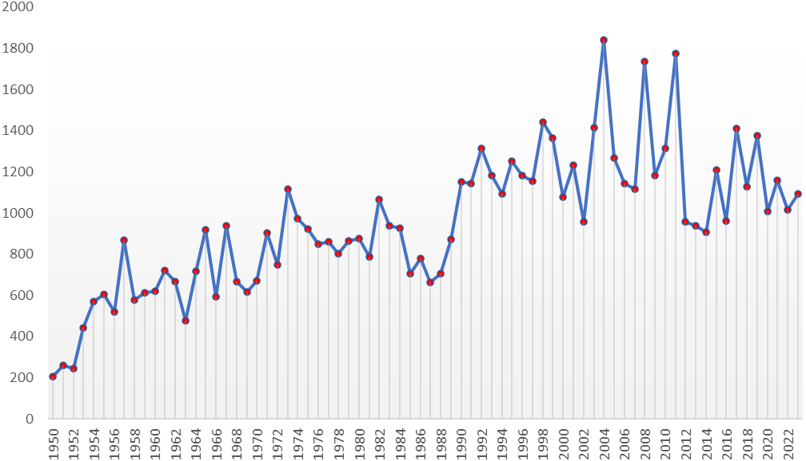

4.2 State-wise Tornado Impact

i. General Description
This objective identifies which U.S. states have been most affected by tornadoes based on frequency. By analyzing state-wise tornado counts, this section helps pinpoint high-risk areas and provides insights into geographical tornado patterns across the country.

ii. Specific Requirements
To perform this analysis accurately:
- The state column was cleaned and standardized to ensure consistency (e.g., removing duplicates, correcting abbreviations).
- Tornado incidents were grouped by state using a Pivot Table.
- The total number of tornadoes in each state was calculated using the COUNT function.
- Sorting was applied to highlight states with the highest tornado activity.
- Slicers were added to filter the visualization based on year, Fujita scale, and month to make the dashboard interactive.

iii. Analysis Results
- The analysis showed that Texas had the highest number of recorded tornadoes, followed closely by Oklahoma, Kansas, and Florida.
- These results are consistent with meteorological patterns and the geographical region known as “Tornado Alley.”
- Some southeastern states, such as Mississippi and Alabama, also showed high tornado activity, confirming recent trends of increased tornado occurrences in those areas.
- The bar chart dynamically adjusted based on slicers, allowing users to explore state-wise tornado impact in specific years or across certain severity levels.

iv. Visualization
A Bar Chart was used to clearly represent the state-wise distribution:
- X-Axis: State Names (sorted by number of tornadoes)
- Y-Axis: Count of Tornadoes
- Chart Type: Map
- Design Features:
  - Bars were color-coded based on frequency for visual emphasis (e.g., darker shade = higher count).
  - Data labels were added on each bar to display exact tornado counts.
  - Axis labels and chart title were formatted in bold for professional presentation.
- Interactive Elements:
  - Slicers connected to this chart allow filtering by year, Fujita scale, and month.
  - The chart responds dynamically to user input, updating in real time and enabling focused state-level analysis.
This visualization clearly communicates the states most vulnerable to tornadoes and provides an interactive way to analyze patterns based on time and tornado intensity.
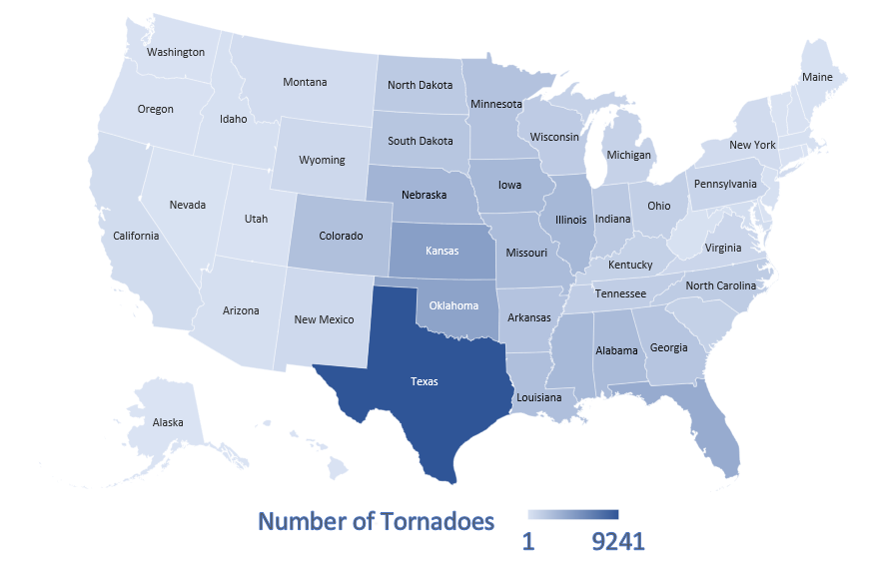

4.3 Fujita Scale Distribution

i. General Description
This objective aims to analyze the severity of tornadoes based on the Fujita Scale, which classifies tornadoes from F0 (weakest) to F5 (strongest). Understanding the distribution across these categories helps identify how often severe tornadoes occur and assess the overall danger level in the dataset.

ii. Specific Requirements
To meet the analysis goal:
- Tornadoes were categorized using the Fujita Scale (F-Scale) column.
- Data was cleaned to ensure all F-Scale entries were consistent (e.g., removing blanks or unclassified values).
- A Pivot Table was created to count the number of tornadoes for each Fujita category (F0–F5).
- The data was sorted in ascending order of the scale (F0 → F5) for better readability.
- Filters/slicers were connected to allow dynamic adjustments by year, state, or month.

iii. Analysis Results
- The majority of tornadoes in the dataset were classified as F0, F1, or F2, representing weaker but more frequent events.
- F3 tornadoes occurred less frequently, while F4 and F5 tornadoes were rare but highly destructive.
- The distribution showed a steep drop-off from low-scale to high-scale tornadoes, indicating that extremely violent tornadoes are outliers but critical to monitor.
- With the help of slicers, users could explore how severity varied by region or year.

iv. Visualization
A Bar Chart was used to display the Fujita Scale distribution:
- X-Axis: Fujita Categories (F0, F1, F2, F3, F4, F5)
- Y-Axis: Count of Tornadoes
- Chart Type: Donut chart
- Color Coding:
  - 🟢 F0–F1 (Weak)
  - 🟡 F2–F3 (Moderate)
  - 🔴 F4–F5 (Violent)
- Design Enhancements:
  - Bars color-coded based on severity for quick visual interpretation.
  - Data labels displayed above each bar to show exact counts.
  - Fujita categories were spaced evenly for clean visual alignment.
- Interactivity:
  - Slicers for year, state, and month allow the user to explore severity patterns across different filters.
  - The chart updates in real-time, giving a dynamic view of tornado strength distribution in any context.
This visualization successfully summarizes the overall severity of tornadoes, highlighting that while most tornadoes are weak, the rare severe ones demand significant attention.

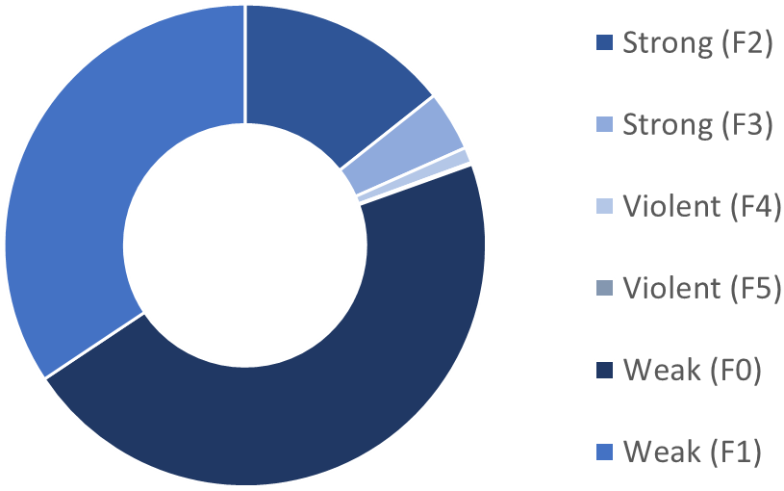

4.4 Injuries & Fatalities Analysis

i. General Description
This objective analyzes the human impact of tornadoes by examining the number of injuries and fatalities they cause. Understanding where and when the most casualties occurred helps assess the humanitarian cost of tornado events and supports disaster response planning.

ii. Specific Requirements
To perform this analysis:
- The dataset fields ‘Injuries’ and ‘Fatalities’ were cleaned — ensuring blank or null entries were treated as 0.
- Tornado data was grouped by state to calculate total injuries and fatalities per state.
- A comparison of injuries vs. fatalities was prepared to understand which states were most affected.
- Slicers were connected to allow filtering by year, Fujita scale, or month to observe time-specific impacts.

iii. Analysis Results
- States such as Alabama, Mississippi, and Missouri recorded high injury and fatality counts, especially in years known for deadly tornado outbreaks.
- In several instances, injury numbers were much higher than fatalities, especially during large but less violent tornadoes.
- Some states with lower tornado frequency still experienced deadly tornadoes, emphasizing the importance of preparedness across all regions.
- Filtering by Fujita scale revealed that F3 and above tornadoes were strongly associated with higher casualty numbers.

iv. Visualization
A Bar Chart was used for this analysis:
- X-Axis: State Names
- Y-Axis: Number of People (Casualties)
- Bars: Two bars per state — one for Injuries, one for Fatalities — for side-by-side comparison
- Chart Type: Clustered Bar Chart
- Design Features:
  - Bars color-coded for clarity (e.g., red for fatalities, orange for injuries).
  - Data labels added to show exact numbers above each bar.
  - Axes and legends clearly labeled for easy interpretation.
- Interactivity:
  - Filters connected to the chart allow users to view casualty data for specific years or tornado strengths.
  - The chart adjusts dynamically to slicer selections, enabling time-based or severity-based casualty analysis.
This visualization clearly presents the human cost of tornadoes and provides a powerful view of how tornado strength and geography influence injuries and fatalities.

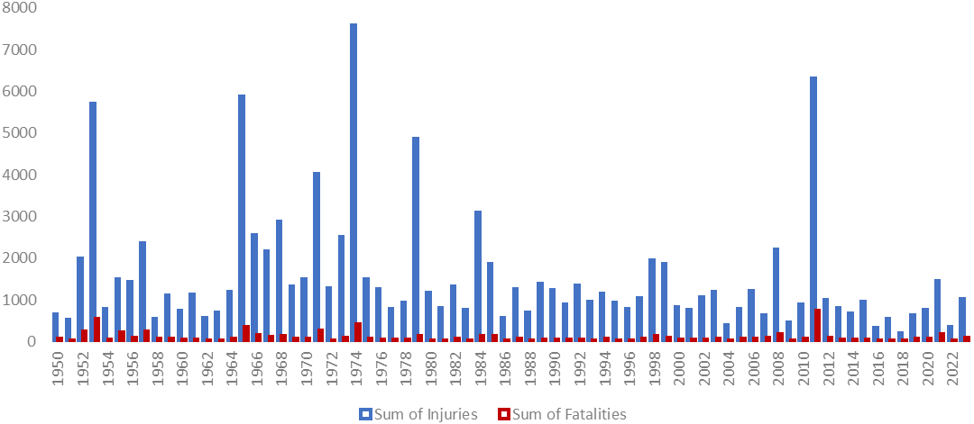

4.5 Financial Impact Analysis

i. General Description
This objective focuses on evaluating the economic damage caused by tornadoes, specifically in terms of property damage and crop damage. It helps in understanding which states or years faced the most financial loss, and how tornadoes affect different sectors of the economy.

ii. Specific Requirements
To ensure accurate financial analysis:
- The Property Loss and Crop Loss fields were cleaned — missing or blank values were converted to 0.
- Tornado incidents were grouped by state to aggregate total economic losses.
- A calculated column for Total Damage was also created for deeper insight.
- Data was formatted with currency symbols for clear financial representation.
- Filters (slicers) were applied for year, month, and Fujita scale for dynamic filtering.

iii. Analysis Results
- States like Texas, Oklahoma, and Alabama had the highest recorded financial damages, often due to a combination of frequent tornadoes and larger property exposure.
- Crop damages were especially significant in agricultural regions such as Kansas and Nebraska.
- Filtering the data by year revealed specific periods (e.g., 2011) with spikes in total damage, corresponding to historically devastating tornado outbreaks.
- Higher Fujita scale tornadoes were generally linked with exponentially greater property damage.

iv. Visualization
A Stacked Bar Chart was used:
- X-Axis: State Names
- Y-Axis: Total Financial Loss (in USD)
- Stacked Segments: Property Loss and Crop Loss
- Chart Type: Vertical Stacked Bar Chart
- Design Features:
  - Currency formatting (e.g., $, K, M) applied to Y-axis values.
  - Data labels on each segment to show detailed financial breakdowns.
  - Color-coding used to differentiate between property (e.g., blue) and crop loss (e.g., green).
- Interactive Elements:
  - Connected slicers for year, Fujita scale, and month allow users to filter financial damage dynamically.
  - Sorting enabled to highlight the most financially impacted states easily.
This visualization gives a powerful, at-a-glance overview of tornado-related financial losses and helps stakeholders understand where resources and recovery funding may be most needed.
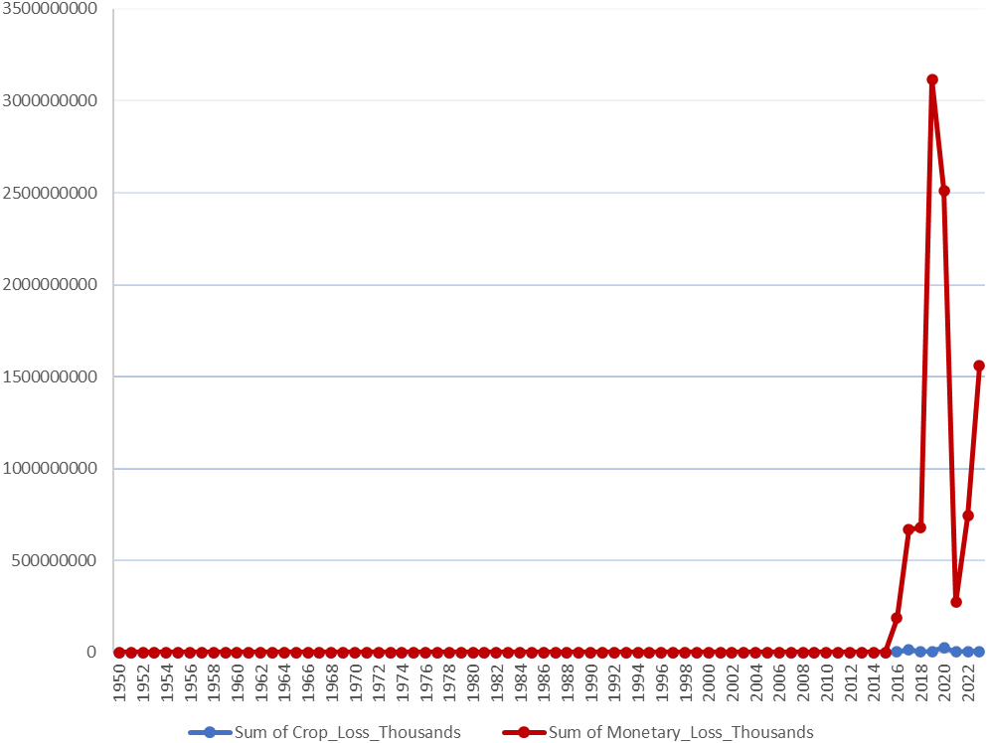

4.6 Peak Tornado Months & Time of Day

i. General Description
This objective analyzes when tornadoes are most likely to occur — both by month of the year and time of day. Recognizing peak tornado times helps emergency services, meteorologists, and communities prepare for and respond to high-risk periods more effectively.

ii. Specific Requirements
For this objective:
- Tornado occurrence data was grouped by Month and separately by Time of Day (converted to hourly bins where necessary).
- Data cleaning included extracting month from the date field and categorizing time into consistent formats (e.g., 00–23 hours).
- Pivot tables were created to count the number of tornadoes per month and per hour.
- Charts were designed to display frequency visually and allow comparison between months and time intervals.
- Filters (slicers) were added to segment this information by state, year, and Fujita scale.

iii. Analysis Results
- The peak months for tornado activity were found to be April, May, and June, aligning with traditional tornado season in the U.S.
- Tornado frequency significantly dropped off in winter months like December and January.
- When analyzing time of day, most tornadoes occurred between 3 PM and 7 PM, likely due to the atmospheric conditions during late afternoon.
- Severe tornadoes (F3 and above) followed similar timing trends, often peaking during those high-energy daylight hours.

iv. Visualization
You used Histograms/Bar Charts to represent this time-based pattern:
- X-Axis (for Month Chart): January to December
- Y-Axis: Count of Tornadoes
- X-Axis (for Time of Day Chart): Hourly bins (e.g., 0–23)
- Chart Type: Vertical Bar Charts / Histograms
- Design Features:
  - Bars labeled with month/hour and tornado count.
  - Color-coded to visually highlight high-frequency periods (e.g., warmer tones for peak times).
  - Grid lines and axis formatting improved for clear comparison.
- Interactive Features:
  - Slicers for state, Fujita scale, and year allowed users to filter and analyze tornado timings for specific regions or event types.
  - Real-time interactivity helped discover anomalies, such as out-of-season tornadoes or unusual activity hours.
These visualizations clearly communicated the seasonal and daily patterns of tornado occurrences and provided users with the ability to dig into specific contexts or timelines interactively.
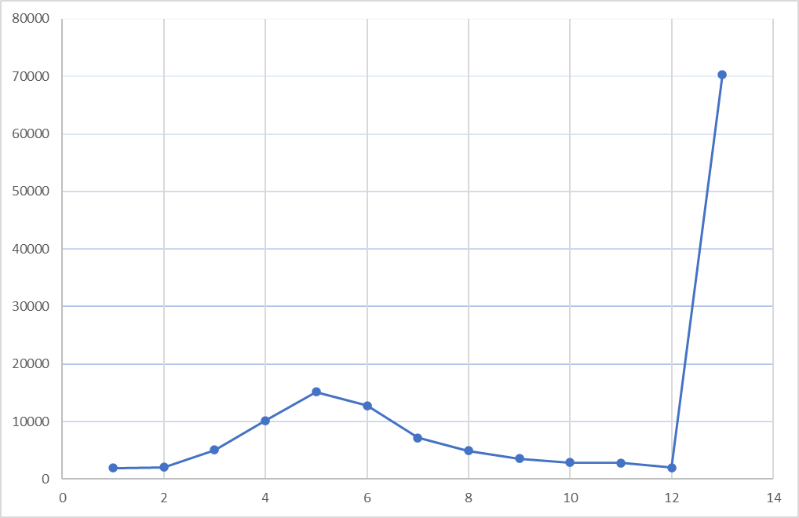

4.7 Correlation Between Tornado Magnitude & Damage

i. General Description
This objective explores the relationship between tornado magnitude (measured using the Fujita Scale) and the resulting damage — including property loss, crop loss, injuries, and fatalities. The goal is to understand how increasing tornado strength impacts human and financial losses.

ii. Specific Requirements
To complete this analysis:
- The Fujita Scale was numerically mapped (e.g., F0 = 0, F1 = 1, ..., F5 = 5) for proper quantitative plotting.
- Relevant fields — Property Loss, Crop Loss, Injuries, and Fatalities — were cleaned and formatted.
- A Scatter Plot was created to plot Fujita Scale on the X-axis and one or more damage indicators on the Y-axis.
- Multiple series were plotted (e.g., separate dots for property loss, injuries, etc.) or analyzed individually through filters.
- Interactivity was enabled through slicers for state, year, and month to refine the view.

iii. Analysis Results
- A clear positive correlation was observed — as the Fujita Scale increased, both property and crop losses tended to increase.
- Similarly, injuries and fatalities were higher for F3–F5 tornadoes compared to weaker ones.
- However, there were a few anomalies, where weaker tornadoes caused high damage due to hitting populated or vulnerable areas.
- This indicates that location and timing also influence damage, not just tornado intensity.

iv. Visualization
You used a Scatter Plot for this correlation analysis:
- X-Axis: Fujita Scale (0 to 5)
- Y-Axis: Selected Damage Metric (Property Loss, Crop Loss, Injuries, or Fatalities)
- Chart Type: Vertical Stacked Bar Chart
- Design Features:
  - Points colored based on the type of damage.
  - Tooltip or data labels show specific values on hover (if applied in Excel).
  - Axis labels and gridlines used for easy interpretation of trends.
- Interactive Features:
  - Users could select different damage types using slicers or filters.
  - Slicers for state, year, and F-Scale range allowed customized correlation analysis across different contexts.
This visualization effectively demonstrates how stronger tornadoes tend to cause more damage — while also highlighting the importance of geographic vulnerability and other real-world factors.
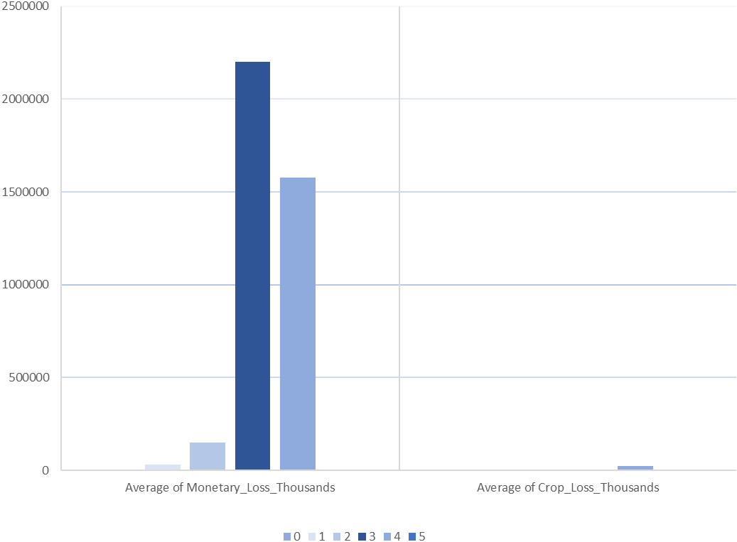

4.8 Average Fujita Scale – Current Tornado Severity Level (Gauge Chart)

i. General Description
This objective focuses on visualizing the average tornado severity using a Gauge Chart. The gauge provides an intuitive, color-coded indicator of how severe tornadoes are in the filtered dataset (based on selected state, year, or month). It serves as a real-time indicator of tornado intensity trends and allows for quick assessments.

ii. Specific Requirements
To implement this:
- A column was created to convert Fujita Scale categories (F0 to F5) into numeric values (0–5) for average calculation.
- A measure was added using Excel formulas or Pivot calculations to compute the average Fujita value dynamically based on current slicer selections.
- The gauge chart was customized to include color bands representing severity levels:
  - 🟢 0–1.4 = Weak (F0–F1)
  - 🟡 1.5–3.4 = Moderate (F2–F3)
  - 🔴 3.5–5 = Violent (F4–F5)
- Slicers were connected for state, month, and year, so the gauge adjusts in real-time.

iii. Analysis Results
- In most filter combinations, the average Fujita Scale remained in the green or yellow zone, indicating a dominance of weaker to moderately severe tornadoes in the dataset.
- When filtering by particularly destructive years or states (e.g., 2011 or Alabama), the needle moved toward the red zone, reflecting higher severity levels.
- This gauge enabled instant recognition of tornado intensity trends based on custom filter conditions.

iv. Visualization
A Gauge Chart was used:
- Value Displayed: Average Fujita Scale
- Needle Position: Points to the current average scale
- Ranges/Colors:
  - Green: 0.0–1.4 (F0–F1)
  - Yellow: 1.5–3.4 (F2–F3)
  - Red: 3.5–5.0 (F4–F5)
- Design Features:
  - Clean, professional design with bold tick marks for each Fujita level.
  - Average value displayed prominently on or above the gauge.
  - Conditional color formatting enhances readability and urgency.
- Interactivity:
  - Fully dynamic — changes based on year, state, or month via slicers.
  - Gives users a quick, visual sense of tornado danger levels in selected contexts.
This gauge chart adds an eye-catching, user-friendly element to the dashboard that enhances interactivity while effectively summarizing tornado severity patterns.

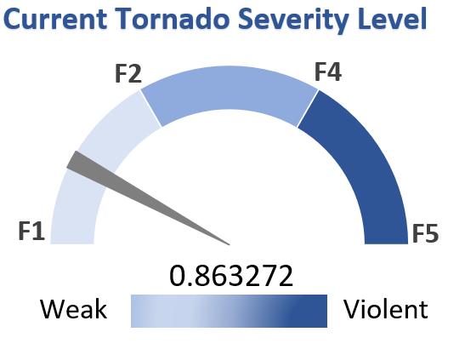

5. Conclusion

This project set out with the objective of designing an advanced, interactive Excel-based dashboard to analyze tornado activity in the United States. From the initial acquisition and preparation of the dataset to the final visualization and interpretation, every step was focused on extracting meaningful insights that could enhance understanding of tornado trends, impacts, and patterns.

Through the implementation of various charts and KPIs, the dashboard allows users to visualize complex multi-dimensional data in a user-friendly format. Each objective was carefully selected and addressed using appropriate chart types—such as line charts, scatter plots, bar graphs, heatmaps, and a gauge chart—based entirely on what was most suitable for the data and the intended insight. These visualizations were further enhanced using interactive slicers, which empowered users to filter and explore data dynamically by state, year, month, or other key variables.

Key outcomes of this analysis include:
- A clear seasonal and annual trend in tornado frequency, highlighting the spring months—particularly April, May, and June—as peak tornado periods.
- Insight into geographical distribution, showing that states such as Texas, Oklahoma, and Kansas experience the highest number of tornadoes, aligning with the region commonly known as Tornado Alley.
- The severity analysis using the Fujita Scale revealed that although the majority of tornadoes fall under weaker categories (F0–F1), the relatively fewer high-intensity events (F4–F5) are disproportionately responsible for widespread destruction.
- The correlation between tornado magnitude and damage showed a general increase in property loss, crop loss, injuries, and fatalities with higher Fujita Scale ratings. However, anomalies in the data also pointed to the role of external factors such as population density and time of day in determining impact.
- A unique feature of the dashboard is the Average Fujita Scale Gauge, which provides a real-time visual indication of tornado severity across different locations and time periods. This element adds an extra layer of usability for both academic users and emergency management stakeholders.

Throughout the project, data integrity and visualization clarity remained top priorities. Raw values were carefully cleaned, missing or non-standardized entries were normalized, and all charts were designed to convey insights quickly and intuitively, without compromising on analytical depth.

This dashboard not only achieves its technical and analytical objectives but also reflects a practical application of data visualization principles in disaster risk analysis. It provides valuable assistance to researchers, meteorologists, emergency response planners, and policy makers by offering an accessible yet detailed overview of tornado dynamics in the U.S.

Ultimately, this project highlights the potential of Excel as a powerful data analysis and visualization tool, capable of transforming raw datasets into actionable intelligence. It also opens the door for future enhancements using predictive modeling, real-time data integration, and geospatial analysis, which could further evolve this dashboard into a comprehensive decision-support system for tornado preparedness and mitigation efforts.

Screenshot of the Dashboard
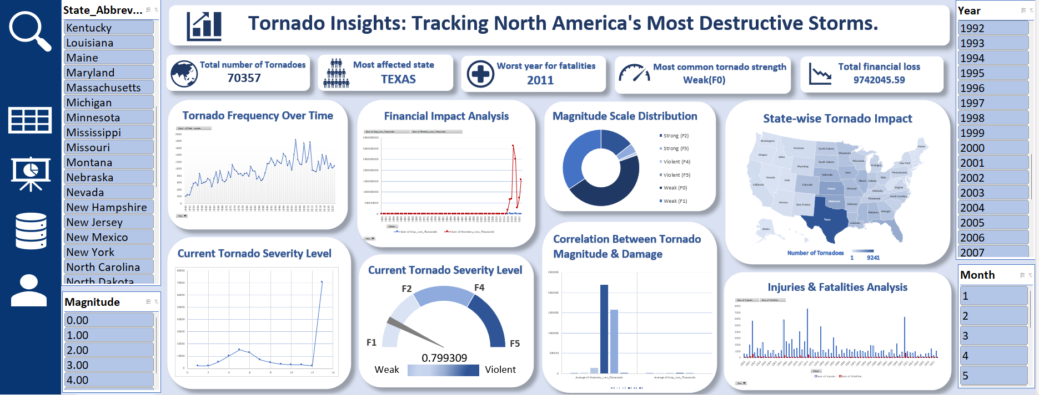

6. Future Scope

While the tornado dashboard developed in this project already offers a robust and insightful platform for visual data exploration, the potential for future enhancement is significant. As data visualization technologies and analytical methodologies evolve, so too does the opportunity to expand the dashboard's capability to become a more intelligent, predictive, and responsive decision-making tool. The following key areas present a compelling roadmap for the dashboard’s continued growth:

1. Integration of Real-Time Tornado Data
Currently, the dashboard is based on historical data. In the future, it could be enhanced by integrating live tornado feeds from organizations like NOAA or NASA through APIs. This would enable real-time tracking of ongoing tornado events, updating severity levels, locations, and casualty data dynamically. Such an enhancement could transform the dashboard into an early warning and situational awareness system for emergency response units.

2. Predictive Analytics and Machine Learning
Advanced analytics techniques, including regression models, decision trees, and clustering, can be integrated using Python or Power BI to forecast tornado probabilities or estimate potential damage. For instance, by analyzing variables such as humidity, temperature, wind speed, and historical tornado patterns, it may be possible to predict future tornado occurrences in specific regions with greater accuracy. This would add a prescriptive and predictive layer to the dashboard, beyond just descriptive statistics.

3. Advanced Geospatial Visualization
While the current dashboard includes basic state-wise tornado impact charts, future iterations could integrate interactive maps using tools such as ArcGIS, Power BI’s Map visuals, or Excel’s 3D Power Map. This would allow users to visualize tornado paths, zones of destruction, and intensity in geographic context. Adding county-level granularity would further improve the depth of spatial analysis.

4. Multi-Device and Web Accessibility
Transitioning the dashboard from Excel to a web-based or mobile-compatible platform would significantly improve usability. Tools like Tableau Public, Power BI Service, or Google Data Studio can be used to host the dashboard online, making it accessible across devices and shareable via links. This would empower users to explore data anywhere, anytime, and enhance collaboration between remote teams or agencies.

5. Personalized Dashboards for Stakeholders
In future versions, the dashboard could support custom user profiles for different audiences—meteorologists, researchers, emergency response teams, government planners, and educators. Each profile could offer tailored views and filters relevant to their needs, e.g., response-focused KPIs for emergency teams, or academic trend analysis for researchers.

6. Deeper Causal Analysis and Social Impact Metrics
Beyond physical damage, future analysis could incorporate socioeconomic data such as population density, infrastructure resilience, income levels, and urban/rural classifications. This would allow for an examination of how these factors influence tornado casualties and recovery rates, contributing to a more holistic understanding of tornado impact.

7. Integration with Public Awareness and Education Tools
The dashboard could include modules for community education, such as interactive simulations, safety instructions, and past case studies. This would not only help professionals but also raise public awareness about tornado safety. Visual storytelling using actual events could help illustrate the importance of early action and preparedness.

8. Automated Reporting and Alert Systems
Future versions could offer automated alerts and report generation, triggered by real-time thresholds (e.g., when average Fujita severity crosses a certain level in a given region). This would support rapid response and proactive risk management, especially during peak tornado seasons.

7. References

[1] National Oceanic and Atmospheric Administration (NOAA), “Storm Events Database,” [Online]. Available: https://www.ncdc.noaa.gov/stormevents/. [Accessed: Apr. 8, 2025].
[2] Federal Emergency Management Agency (FEMA), “Tornadoes,” [Online]. Available: https://www.fema.gov/emergency-managers/risk-management/hazards/tornadoes. [Accessed: Apr. 5, 2025].
[3] Microsoft Corporation, “Use a PivotTable to analyze worksheet data,” [Online]. Available: https://support.microsoft.com/en-us/excel. [Accessed: Apr. 7, 2025].
[4] A. L. Houston and R. E. Wilhelmson, “The Evolution of a Tornado: A Radar Analysis,” Bulletin of the American Meteorological Society, vol. 83, no. 4, pp. 567–584, Apr. 2002.
[5] T. C. Peterson et al., “State of the Climate in 2011,” Bulletin of the American Meteorological Society, vol. 93, no. 7, pp. S1–S179, Jul. 2012.
[6] Excel Campus, “How to Create a Gauge Chart in Excel,” [Online]. Available: https://www.excelcampus.com/charts/gauge-speedometer/. [Accessed: Apr. 9, 2025].
[7] Peltier Tech, “Excel Charting Techniques for Dynamic Dashboards,” [Online]. Available: https://peltiertech.com/. [Accessed: Apr. 9, 2025].
[8] U.S. Department of Commerce, “Enhanced Fujita Scale,” National Weather Service, [Online]. Available: https://www.weather.gov/oun/efscale. [Accessed: Apr. 6, 2025].
[9] R. Edwards, “Tornado Intensity Estimation: Past, Present, and Future,” Electronic Journal of Severe Storms Meteorology, vol. 7, no. 2, pp. 1–22, 2012.
[10] K. E. Klockow, S. L. Donner, and B. D. McNoldy, “How to Communicate Tornado Risk: Lessons from the 2011 Joplin Tornado,” Weather, Climate, and Society, vol. 6, no. 4, pp. 593–598, Oct. 2014.
[11] D. J. Stensrud et al., “Progress and Challenges with Warn-on-Forecast,” Bulletin of the American Meteorological Society, vol. 94, no. 10, pp. 1639–1664, Oct. 2013.
[12] National Severe Storms Laboratory (NSSL), “Understanding Severe Weather: Tornado Basics,” [Online]. Available: https://www.nssl.noaa.gov/education/svrwx101/tornadoes/. [Accessed: Apr. 8, 2025].
[13] ExcelJet, “Excel Slicers – A Complete Guide,” [Online]. Available: https://exceljet.net/excel-slicers. [Accessed: Apr. 6, 2025].
[14] M. Fewster, “Visualizing Uncertainty: Tornado Plots and Data Narratives,” Journal of Data Visualization, vol. 3, no. 1, pp. 45–62, 2020.
[15] L. Wilkinson, “The Grammar of Graphics,” Statistics and Computing, vol. 8, no. 3, pp. 183–186, Sep. 1998.
[16] D. Wicklin, “Visualizing Big Weather Data with SAS and Open Datasets,” Proceedings of the SAS Global Forum, 2018.
[17] Federal Communications Commission (FCC), “The Role of Geographic Data in Emergency Preparedness,” [Online]. Available: https://www.fcc.gov/emergency-geodata. [Accessed: Apr. 9, 2025].
[18] D. McCandless, “Information is Beautiful: Visualizing Risk,” [Online]. Available: https://informationisbeautiful.net. [Accessed: Apr. 7, 2025].

